**Hexa Pirate’s Code**

***Misc***

**Challenge:**

Set sail on a digital adventure as you uncover the ancient Pirate's Code. The code is shrouded by Hexa, a language known to only the savviest of pirates. Can you decode the hidden message and claim your prize?

Attached - Hexa_Pirates_Code.zip

**Approach:**

The zip file contains a lot of files with weird names, all hex coded or something?

We try to decode the file names but get nothing good. We open a random file to see there’s some sort of script written.

If we open other files and look closely, we’ll notice almost all files have the same thing written in it, EXCEPT, this one line i noticed and it looks interesting:

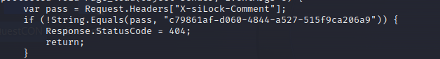

We use grep to extract this line from all the files and get:

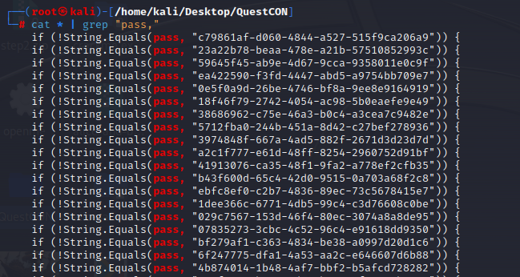

Our intuition was right, the pass is compared to different strings in different files.

Now all the strings look hex encoded but when decoded reveals nothing sensible :/

Except, this one line which looks different from other lines:

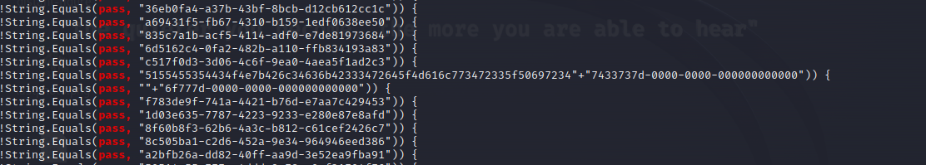

We decode this hex string to get our flag which would be:

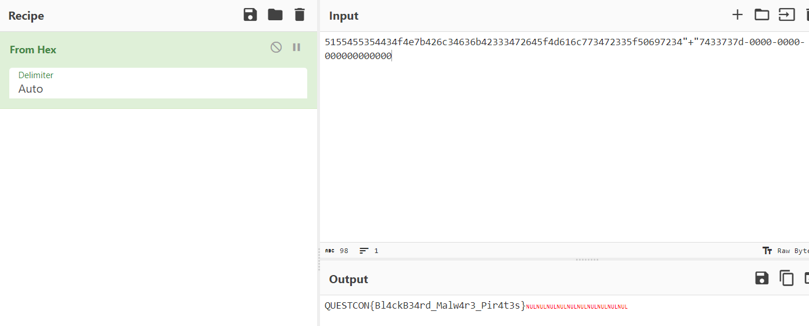

**Flag: QUESTCON{Bl4ckB34rd_Malw4r3_Pir4t3s}**

This could be considered as luck maybe? That I considered looking for all the passwords the files were checking for? But yeah it took me a lot of time to actually reach this conclusion.

Congrats!!

Happy Hacking!